Lab8 Interrupt

Name : Yi Zihong ID : U201613634

**Part One**

In this lab, I uses the FPGA to add numbers with timer and button interrupt.

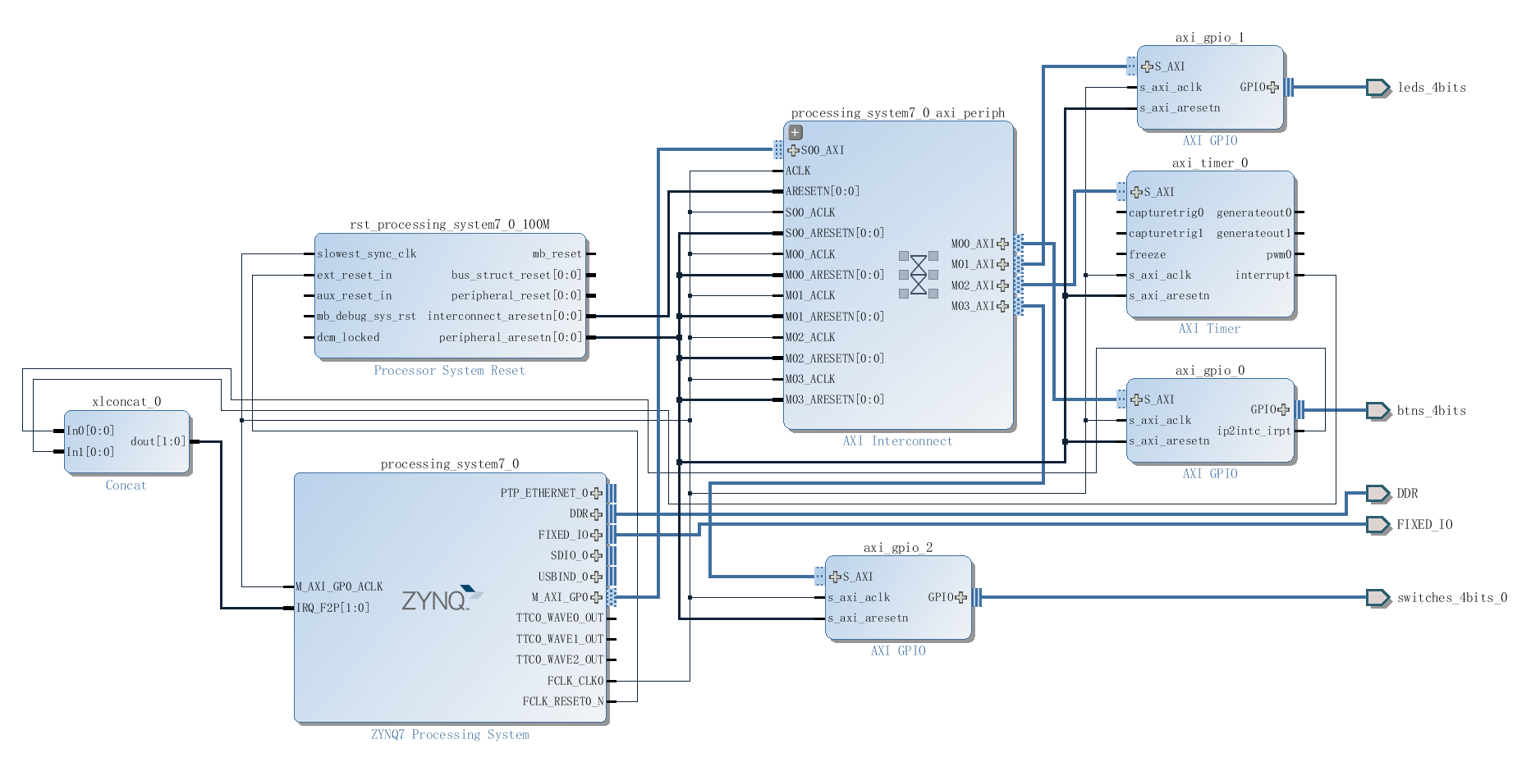

**Part Two**

In this lab, I finished the Ping-Pong game with timer and button interrupt. Also it can change the speed with reading the values of switches. These are my code.

1. /*
2. * interrupt_counter_tut_2B.c
3. *
4. *  Created on:     Unknown
5. *      Author:     Ross Elliot
6. *     Version:     1.1
7. */
9. /********************************************************************************************
11. * VERSION HISTORY
12. ********************************************************************************************
13. *   v1.1 - 01/05/2015
14. *       Updated for Zybo ~ DN
15. *
16. *   v1.0 - Unknown
17. *       First version created.
18. *******************************************************************************************/
20. #include "xparameters.h"
21. #include "xgpio.h"
22. #include "xtmrctr.h"
23. #include "xscugic.h"
24. #include "xil_exception.h"
25. #include "xil_printf.h"
26. #include "XScuTimer.h"
28. // Parameter definitions
29. #define INTC_DEVICE_ID      XPAR_PS7_SCUGIC_0_DEVICE_ID
30. #define TMR_DEVICE_ID       XPAR_TMRCTR_0_DEVICE_ID
31. #define BTNS_DEVICE_ID      XPAR_AXI_GPIO_0_DEVICE_ID
32. #define LEDS_DEVICE_ID      XPAR_AXI_GPIO_1_DEVICE_ID
33. #define SWITCES_DEVICE_ID   XPAR_AXI_GPIO_2_DEVICE_ID
34. #define INTC_GPIO_INTERRUPT_ID XPAR_FABRIC_AXI_GPIO_0_IP2INTC_IRPT_INTR
35. #define INTC_TMR_INTERRUPT_ID XPAR_FABRIC_AXI_TIMER_0_INTERRUPT_INTR
37. #define BTN_INT             XGPIO_IR_CH1_MASK
38. #define TMR_LOAD            0xF8000000
40. #define RESETBUTTON 0b0100
41. #define STARTBUTTON 0b0010
42. #define LEFTPADDLE 0b1000
43. #define RIGHTPADDLE 0b0001
45. #define LED_PATTERNS_ORDER_LEFT_OUT 0
46. #define LED_PATTERNS_ORDER_RIGHT_OUT 5
48. #define Paddle_Left 1
49. #define Paddle_Right 4
51. #define START 1
52. #define STOP 0
53. #define LEFT 0
54. #define RIGHT 1
56. #define ONE_TENTH 32500000 // half of the CPU clock speed/10
58. **int** LED_PATTERNS_ORDER[6] = { 0b0000, 0b1000, 0b0100, 0b0010, 0b0001, 0b0000 };
60. XGpio LEDInst, BTNInst;
61. XScuGic INTCInst;
62. XTmrCtr TMRInst;
63. **static** **int** btn_value;
64. **static** **int** tmr_count;
66. **static** **int** scoreright;
67. **static** **int** scoreleft;
68. //----------------------------------------------------
69. // PROTOTYPE FUNCTIONS
70. //----------------------------------------------------
71. **static** **void** BTN_Intr_Handler(**void** *baseaddr_p);
72. **static** **void** TMR_Intr_Handler(**void** *baseaddr_p);
73. **static** **int** InterruptSystemSetup(XScuGic *XScuGicInstancePtr);
74. **static** **int** IntcInitFunction(u16 DeviceId, XTmrCtr *TmrInstancePtr, XGpio *GpioInstancePtr);
76. //----------------------------------------------------
77. // INTERRUPT HANDLER FUNCTIONS
78. // - called by the timer, button interrupt, performs
79. // - LED flashing
80. //----------------------------------------------------
81. **char** GameOver, StartDirection;
82. **int** led_order;
83. XGpio dip;
84. XScuTimer Timer; /* Cortex A9 SCU Private Timer Instance */
85. XScuTimer *TimerInstancePtr = &Timer;
86. **int** dip_check, dip_check_prev;
88. **int** number = 3;
90. **void** BTN_Intr_Handler(**void** *InstancePtr)
91. {
92. // Disable GPIO interrupts
93. XGpio_InterruptDisable(&BTNInst, BTN_INT);
94. // Ignore additional button presses
95. **if** ((XGpio_InterruptGetStatus(&BTNInst) & BTN_INT) !=
96. BTN_INT) {
97. **return**;
98. }
99. btn_value = XGpio_DiscreteRead(&BTNInst, 1);
101. **switch**(btn_value){
102. **case** RESETBUTTON:
103. xil_printf("\n\rNew Game - Scores Reset\r\n");
104. scoreright = 0;
105. scoreleft = 0;
106. GameOver = STOP;
107. xil_printf("Score Left = %d Score Right = %d\r\n", scoreright,scoreleft);
108. **break**;
110. **case** STARTBUTTON:
112. GameOver = START; //start game
114. **break**;
116. **case** LEFTPADDLE:
117. **if** (led_order != Paddle_Left) {
119. xil_printf("Press too early !\r\n");
120. StartDirection = RIGHT;
121. GameOver = STOP;
122. led_order = LED_PATTERNS_ORDER_LEFT_OUT;
123. XGpio_DiscreteWrite(&LEDInst, 1,  LED_PATTERNS_ORDER[led_order]);
124. scoreright += 1;
125. xil_printf("Score  = Left = %d Score Right %d\r\n", scoreleft, scoreright);
127. } **else** {
128. StartDirection = RIGHT;
129. scoreright += 1;
130. XGpio_DiscreteWrite(&LEDInst, 1,  LED_PATTERNS_ORDER[led_order]);
131. xil_printf("Score  = Left = %d Score Right %d\r\n", scoreleft, scoreright);
132. }
134. **break**;
136. **case** RIGHTPADDLE:
137. **if** (led_order != Paddle_Right) {
138. StartDirection = LEFT;
139. GameOver = STOP;
141. xil_printf("Press too early !\r\n");
142. led_order = LED_PATTERNS_ORDER_RIGHT_OUT;
143. XGpio_DiscreteWrite(&LEDInst, 1,  LED_PATTERNS_ORDER[led_order]);
144. scoreleft += 1;
145. xil_printf("Score  = Left = %d Score Right %d\r\n", scoreleft, scoreright);
146. } **else** {
147. StartDirection = LEFT;
148. scoreright += 1;
149. XGpio_DiscreteWrite(&LEDInst, 1,  LED_PATTERNS_ORDER[led_order]);
150. xil_printf("Score  = Left = %d Score Right %d\r\n", scoreleft, scoreright);
151. }
152. **break**;
154. **default**:**break**;
155. }
157. (**void**)XGpio_InterruptClear(&BTNInst, BTN_INT);
158. // Enable GPIO interrupts
159. XGpio_InterruptEnable(&BTNInst, BTN_INT);
160. }
162. **void** TMR_Intr_Handler(**void** *data)
163. {
164. **if** (XTmrCtr_IsExpired(&TMRInst,0)){
165. // Once timer has expired 3 times, stop, increment counter
166. // reset timer and start running again
167. **if**(tmr_count == number*10){
169. //judge different directions
170. **if** (GameOver != STOP){
171. **switch**(StartDirection){
173. **case** LEFT:
174. XTmrCtr_Stop(&TMRInst,0);
175. tmr_count = 0;
177. led_order--;
178. XGpio_DiscreteWrite(&LEDInst, 1,  LED_PATTERNS_ORDER[led_order]);
179. **if**(led_order == LED_PATTERNS_ORDER_LEFT_OUT){
180. scoreright += 1;
181. xil_printf("Score  = Left = %d Score Right %d\r\n", scoreleft, scoreright);
182. GameOver = STOP;
183. StartDirection = RIGHT;
184. }
185. XTmrCtr_Reset(&TMRInst,0);
186. XTmrCtr_Start(&TMRInst,0);
187. **break**;
189. **case** RIGHT:
190. XTmrCtr_Stop(&TMRInst,0);
191. tmr_count = 0;
193. led_order++;
194. XGpio_DiscreteWrite(&LEDInst, 1,  LED_PATTERNS_ORDER[led_order]);
196. **if**(led_order == LED_PATTERNS_ORDER_RIGHT_OUT){
197. scoreleft += 1;
198. xil_printf("Score  = Left = %d Score Right %d\r\n", scoreleft, scoreright);
200. GameOver = STOP;
201. StartDirection = LEFT;
202. }
204. XTmrCtr_Reset(&TMRInst,0);
205. XTmrCtr_Start(&TMRInst,0);
206. **break**;
208. **default**:**break**;
209. }
210. }
211. } **else** {
212. tmr_count++;
213. xil_printf("tmr_count %d\r\n", tmr_count);
214. }
215. }
216. }


220. //----------------------------------------------------
221. // MAIN FUNCTION
222. //----------------------------------------------------
223. **int** main (**void**)
224. {
225. **int** status;
226. //initialize variables, timers, ports
227. XGpio_Initialize(&dip, SWITCES_DEVICE_ID);
228. XGpio_SetDataDirection(&dip, 1, 0xffffffff);
230. //----------------------------------------------------
231. // INITIALIZE THE PERIPHERALS & SET DIRECTIONS OF GPIO
232. //----------------------------------------------------
233. // Initialise LEDs
234. status = XGpio_Initialize(&LEDInst, LEDS_DEVICE_ID);
235. **if**(status != XST_SUCCESS) **return** XST_FAILURE;
236. // Initialise Push Buttons
237. status = XGpio_Initialize(&BTNInst, BTNS_DEVICE_ID);
238. **if**(status != XST_SUCCESS) **return** XST_FAILURE;
239. // Set LEDs direction to outputs
240. StartDirection = RIGHT;
241. led_order = 1;
242. XGpio_DiscreteWrite(&LEDInst, 1,  LED_PATTERNS_ORDER[led_order]);
244. //----------------------------------------------------
245. // SETUP THE TIMER
246. //----------------------------------------------------
247. status = XTmrCtr_Initialize(&TMRInst, TMR_DEVICE_ID);
248. **if**(status != XST_SUCCESS) **return** XST_FAILURE;
249. XTmrCtr_SetHandler(&TMRInst, TMR_Intr_Handler, &TMRInst);
250. XTmrCtr_SetResetValue(&TMRInst, 0, TMR_LOAD);
251. XTmrCtr_SetOptions(&TMRInst, 0, XTC_INT_MODE_OPTION | XTC_AUTO_RELOAD_OPTION);
253. // Initialize interrupt controller
254. status = IntcInitFunction(INTC_DEVICE_ID, &TMRInst, &BTNInst);
255. **if**(status != XST_SUCCESS) **return** XST_FAILURE;
257. XTmrCtr_Start(&TMRInst, 0);
258. xil_printf("\n\rInit all finished\r\n");

261. **while**(1){
262. dip_check = XGpio_DiscreteRead(&dip, 1);
263. **if** (dip_check != dip_check_prev) {
264. xil_printf("DIP Switch Status %x, %x\r\n", dip_check_prev,
265. dip_check);
266. dip_check_prev = dip_check;
267. number = dip_check;
268. }
269. }
271. **return** 0;
272. }
274. //----------------------------------------------------
275. // INITIAL SETUP FUNCTIONS
276. //----------------------------------------------------
278. **int** InterruptSystemSetup(XScuGic *XScuGicInstancePtr)
279. {
280. // Enable interrupt
281. XGpio_InterruptEnable(&BTNInst, BTN_INT);
282. XGpio_InterruptGlobalEnable(&BTNInst);
284. Xil_ExceptionRegisterHandler(XIL_EXCEPTION_ID_INT,
285. (Xil_ExceptionHandler)XScuGic_InterruptHandler,
286. XScuGicInstancePtr);
287. Xil_ExceptionEnable();

290. **return** XST_SUCCESS;
292. }
294. **int** IntcInitFunction(u16 DeviceId, XTmrCtr *TmrInstancePtr, XGpio *GpioInstancePtr)
295. {
296. XScuGic_Config *IntcConfig;
297. **int** status;
299. // Interrupt controller initialisation
300. IntcConfig = XScuGic_LookupConfig(DeviceId);
301. status = XScuGic_CfgInitialize(&INTCInst, IntcConfig, IntcConfig->CpuBaseAddress);
302. **if**(status != XST_SUCCESS) **return** XST_FAILURE;
304. // Call to interrupt setup
305. status = InterruptSystemSetup(&INTCInst);
306. **if**(status != XST_SUCCESS) **return** XST_FAILURE;
308. // Connect GPIO interrupt to handler
309. status = XScuGic_Connect(&INTCInst,
310. INTC_GPIO_INTERRUPT_ID,
311. (Xil_ExceptionHandler)BTN_Intr_Handler,
312. (**void** *)GpioInstancePtr);
313. **if**(status != XST_SUCCESS) **return** XST_FAILURE;

316. // Connect timer interrupt to handler
317. status = XScuGic_Connect(&INTCInst,
318. INTC_TMR_INTERRUPT_ID,
319. (Xil_ExceptionHandler)TMR_Intr_Handler,
320. (**void** *)TmrInstancePtr);
321. **if**(status != XST_SUCCESS) **return** XST_FAILURE;
323. // Enable GPIO interrupts interrupt
324. XGpio_InterruptEnable(GpioInstancePtr, 1);
325. XGpio_InterruptGlobalEnable(GpioInstancePtr);
327. // Enable GPIO and timer interrupts in the controller
328. XScuGic_Enable(&INTCInst, INTC_GPIO_INTERRUPT_ID);
330. XScuGic_Enable(&INTCInst, INTC_TMR_INTERRUPT_ID);
332. **return** XST_SUCCESS;
333. }